Specification Documentation

SUPPLIER PORTAL

Solace Technology Pty Ltd

|  |  |
| --- | --- |
| **Version:** | 1.1 |
| **Author:** | Christie Glasson |
| **Date:** | 16/06/2015 |

This document provides a high level overview of the supplier experience in terms of their interaction with the Business through the Supplier Portal

# Version Control

The following is a list all changes made to this document, the person making the change, the new version number and the reason why the change was necessary.

| Date | Author | Version | Change Description |
| --- | --- | --- | --- |
| 16/06/2015 | CG | 1.1 | First Draft |
|  |  |  |  |
|  |  |  |  |

# Distribution List

The following list contains the names and organisational details of the people to whom this document has been distributed.

| Name | Organisation |
| --- | --- |
| Andrew Lombe | Solace Technology |
| Lyndal Johnson | Solace Technology |
| Ian Barry | Solace Technology |
| Christie Glasson | Solace Technology |
| Ed Lombe | Myco Systems |
| Saurav Acharjee | Myco Systems |

# Table of Contents

1. Version Control 2

2. Distribution List 3

3. Table of Contents 4

4. Terms and Naming Conventions 5

5. Purpose & Business Process Description 6

5.1 Background & Purpose 6

5.2 Business Data Model 6

6. Scope 7

6.1 Scope defined using the Business Data Model 7

7. Description 8

7.1 Supplier Portal Overview 8

7.2 User Platforms 9

7.3 User Characteristics 9

8. Product/Property Categories 10

8.1 Category 1 – ‘Live’ Products 10

8.2 Category 2 – ‘Request’ Products 11

8.3 Category 3 – ‘Live’ Property 12

8.4 Category 4 – ‘Request’ Property 14

9. Features 15

10. High Level Experience Flows 19

# Terms and Naming Conventions

The following table contains a list of the terms specific to the project:

| Term | Definition |
| --- | --- |
| *Solace* | Describes the entire system instance to each individual Solace Technology Pty Ltd client. |
| *The Business* | Solace Technology Pty Ltd client using an instance of Solace. |
| *The Supplier* | Any business that has a commercial relationship with The Business in terms of making available property or products for sale through The Business in exchange for a commission. |
| *The Agent* | Any business that has a commercial relationship with The Business in terms of selling property or products supplied by The Supplier in exchange for a commission. |
| *The Guest* | An end user purchasing a holiday experience based on the offerings of The Supplier, though the Business. This transaction can be facilitated through The Business, the Guest Portal, The Agent or other sites powered by Channel Managers that are interacting with Solace. |
| *Business Console* | A web based Solace interface used by The Business to facilitate bookings, administration and management of Solace. Branded Solace and used by The Business’ staff and consultants. |
| *Agent Portal* | A web based Solace interface used by The Agent to facilitate bookings completed on behalf of The Business. Business Branded and used by The Agent’s staff and consultants. |
| *Supplier Portal* | A web based Solace interface used by The Supplier to facilitate the management of product and/or property offerings available for sale through Solace. Business branded and used by The Supplier’s staff. |
| *Guest Portal* | A web based Solace interface used by The Guest to facilitate the purchase of property and/or product. Enables The Guest to search, purchase, pay for, amend and cancel offerings using an intuitive, clean, secure, mobile responsible site. Business branded. |

# Purpose & Business Process Description

## Background & Purpose

Solace is a cloud based, reservation system that is unique in the way it delivers multiple property and product offerings from 3rd party suppliers, facilitates the bundling of these offerings to a retail client through a streamlined, seamless, single transaction. This could be delivered to The Guest via direct contact with The Business and utilisation of the Business Console, via The Agent utilising the Agent Portal, or managed themselves using the Guest Portal.

Solace manages the payments into The Business by The Guest and The Agent, calculates taxes and commissions, and manages the distribution of funds to The Supplier based on their specific terms of payment.

Solace allows integration with accommodation Channel Managers such as SiteMinder, RTP for Ski Resort product sales, and other 3rd party systems such as Alpine Sports Ski Rental system on a “pay to connect” basis. The purpose of integrating with these systems is to reduce data duplication, reduce manual data entry and improve The Guest’s booking experience.

## Business Data Model

The below diagram shows the interaction of the various users with each other and with Solace.

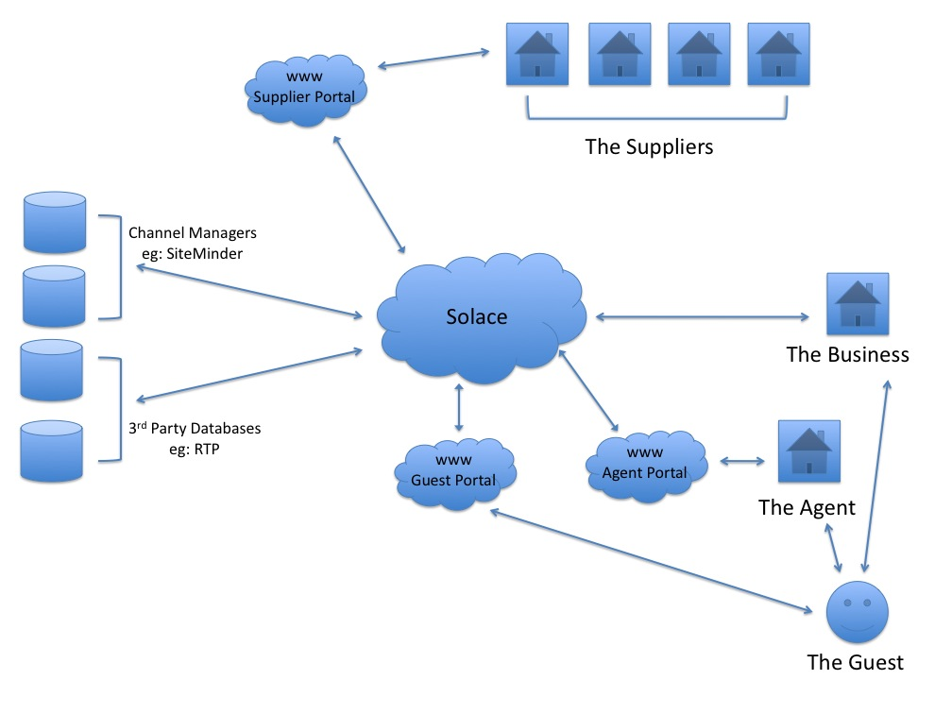

# Scope

This document is solely focused on the Supplier Portal interface to Solace and does not provide an overall description Solace in its entirety.

## Scope defined using the Business Data Model

Below is the Business Data Model that highlights the module/s that are covered within the scope of this document.

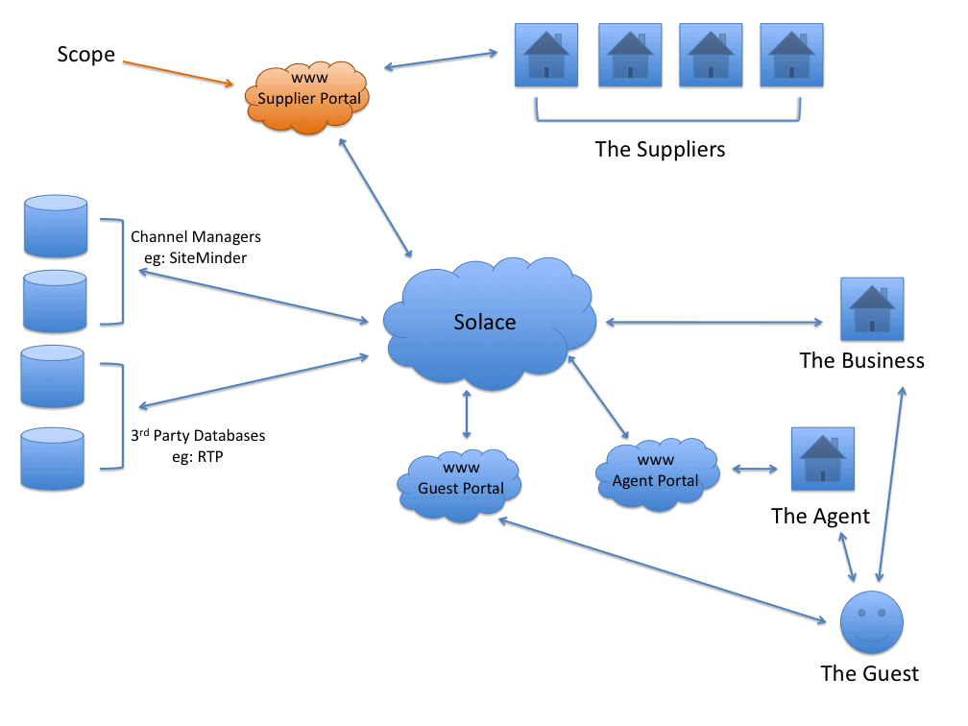

# Description

## Supplier Portal Overview

The Supplier Portal is integrated into the Business website and allows Property Owners, Activity Providers or Tour Operators the following experiences:

* Ability to manage their contact and business details including changing their password to Supplier Portal
* Upload and update their product/property description, images, pricing, inventory (where applicable), google map location, terms & conditions for display on the Business website after the Business ‘approves’ the content
* Upload and update arrival instructions for inclusion in automatic confirmation emails to guests from the Business after the Business ‘approves’ the content
* Allow for bulk upload of images
* Allow Suppliers to add events/products to the Business’ Events Calendar after the Business ‘approves’ the content
* Provide functionality for Suppliers to ‘block out’ periods where their product is unavailable
* Produce QR Codes or Vouchers (PDFs) emailed to guests in their final confirmation from the Business to be used by guests for the redemption of product bookings
* Provide a tool to allow Suppliers to communicate with Guests via email without releasing the Guests’ email address
* In the instance of a property or an inventoried product, provide an interactive calendar to display product/property availability and pricing, allow Suppliers to view current bookings details and their status, or make their own owner bookings
* Provide Suppliers with a range of reports including forward bookings, invoices, payments, booking history etc
* In the instance of properties that are managed by the Business, provide access to a Job Log to inform the Supplier of current and upcoming maintenance items registered by the Business, or to allow the Supplier to request their own Job request with The Business
* Notify the Supplier by email of new bookings
* Notify the Supplier by email of remittance of payment from the Business
* Notify the Supplier by email of a pending Guest review and invite them to participate in the review and approval process

## User Platforms

All features of the Supplier Portal must be available and fully functional from all devices. The look and feel between devices needs to be consistent and provide a seamless experience.

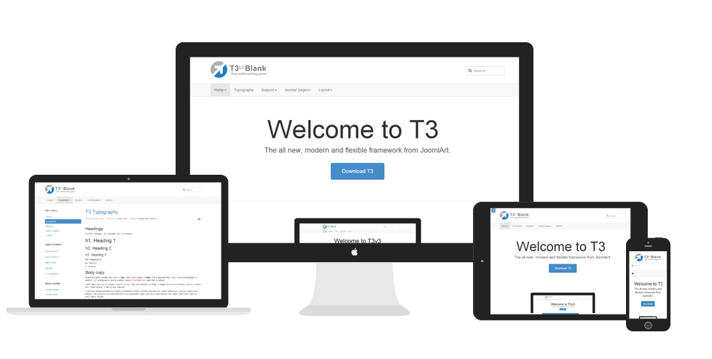

## User Characteristics

The Supplier Portal will be used by businesses who wish to sell their products/properties through the Business in return for a commission.

Examples of participating businesses include:

* Accommodation providers including, but not limited to, hotels, motels, lodges, cabins, caravan parks, self contained houses, and apartments.
* Tour operators
* Ski resorts
* Day Spas
* Restaurants/Cafes
* Transport operators
* Experience providers

The main characteristic that all Suppliers will share is that their product/property offerings will be appropriate in a destination holiday market. From there, products/properties can be categorised into four distinct groups. Each of these product categories transact within Solace in their own unique ways.

An individual Supplier may only have products pertaining to a single category, or they may offer a range of products across multiple product categories.

# Product/Property Categories

As described in section 7.3, product/property offerings from a Supplier can be categorised into four distinct groups. Each category will dictate how the product is set up within, and interacts with Supplier Portal and the broader Solace system.

It is important to note that an individual Supplier may offer one or many products belonging to the same product category, or may offer multiple products from multiple product categories.

## Category 1 – ‘Live’ Products

Products belonging to this category are activity products (not accommodation) that are similar in that they can be immediately be confirmed upon receipt of payment (according to payment terms). They fall into three sub-categories:

**1) Inventoried products managed through Supplier Portal**

An example of this type of product would be a fishing charter offered by Fishing Charter business who manages their tour inventory within their Supplier Portal.

Suppliers input direct bookings (bookings that have not come from the Business) into Supplier Portal as owner bookings so their inventory levels are always up to date.

Bookings made by guests will be immediately confirmed upon receipt of payment without any further input required on behalf of the Supplier.

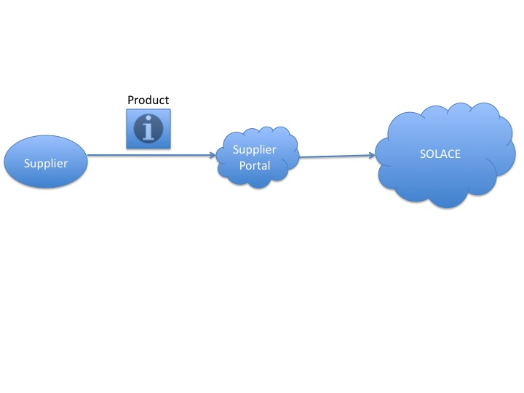

Diagram 8.1.1 – Inventoried products managed through Supplier Portal

**2) Products with unlimited supply**

A Supplier may have a product offering that has an unlimited supply. An unlimited supply also allows for immediate confirmation upon payment of booking. An example of this type of product would be a gift voucher or a vehicle entry fee.

**3) Products offered via an integrated 3rd party system**

Examples of this type of product would be lift tickets and ski hire products offered by a ski resort Supplier through RTP. RTP manages the resort’s product offerings, descriptions, images and inventory levels where applicable, and Solace ‘pulls’ this information directly from this 3rd party system.

Bookings made through Solace are instantly stored with the Supplier’s 3rd party system, updating their inventory accordingly if required.

As Solace effectively has access to ‘live’ inventory data, products offered through an integrated 3rd party system can also be confirmed as soon as the product has reached satisfactory payment terms without any input required from the Supplier.

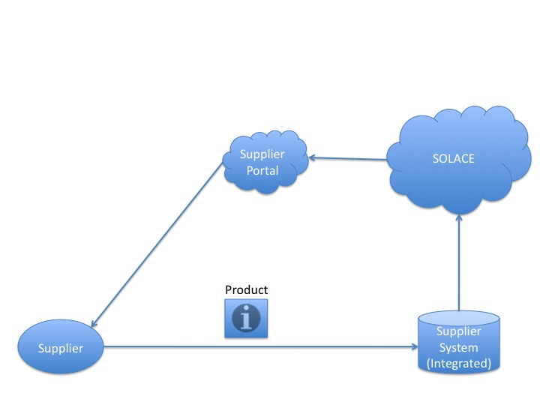

Diagram 8.1.3 – Products offered via an integrated 3rd party system

## Category 2 – ‘Request’ Products

Products belonging to this category are also activity based products as opposed to accommodation. The Supplier is not able or willing to provide inventory on their products that may be of limited supply, and they do not operate a system that can integrate with Solace.

To avoid disappointment and refunds, payments from guests are withheld from processing until the Supplier ‘approves’ the booking through Supplier Portal.

If the booking cannot be fulfilled, the Supplier can ‘deny’ the booking or offer a guest an alternative time. It is only after the Guest accepts the offer from the Supplier (via Guest Portal) that the Guest’s card is charge and the product purchase confirmed. If the guest does not accept the changes, then the product booking is cancelled with no money exchange required.

An example of this type of product may be a horse riding tour offered by a horse riding company. There is limited supply, but the Supplier is not interested in utilising Supplier Portal to manage their tour numbers. They are happy to accept bookings from the Business and prefer to check their availability in their own system each time a reservation is received through Supplier Portal.

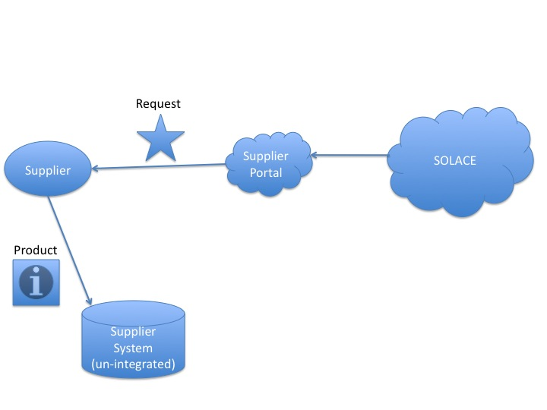

Diagram 8.2 – Request Products

## Category 3 – ‘Live’ Property

As with ‘Live Products’, ‘Live Properties’ can be immediately confirmed upon receipt of payment (according to payment terms). Solace can access to the inventory data in a variety of methods as described in the below sub-categories:

**1) Property hosted with Solace**

An example of this type of property is a holiday house rental. The holiday house owner inputs direct bookings (bookings that have not come from the Business) into Supplier Portal as owner bookings or blocks out dates where the property is unavailable so their inventory levels are always up to date.

These properties have the ability to ‘push’ property information, photos, pricing and inventory to Channel Managers with Solace managing these elements through Supplier Portal.

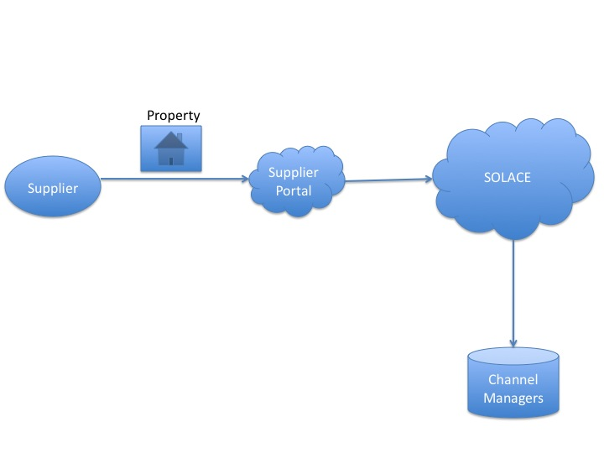

Diagram 8.3.1 – Property hosted with Solace

**2) Property hosted through a Channel Manager**

A property within this category may have a Supplier who is willing to use the Business as another sales channel, but does not want to manage their property information, photos, pricing and inventory through Supplier Portal as they are already doing it elsewhere.

These properties are already using one or more Channel Managers and are managing these Channels independently of Solace.

In this instance, Solace will have the ability to ‘pull’ property data from a specified Channel Manager in order to sell it.

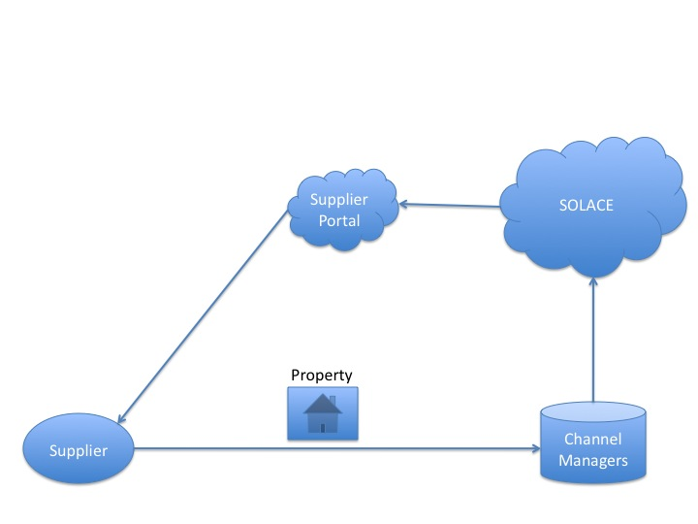

Diagram 8.3.2 – Property hosted through a Channel Manager

## Category 4 – ‘Request’ Property

A property of this category belongs to a Supplier who is not using a Channel Manager and has no interest in updating inventory through Supplier Portal. The property’s information, photos and pricing are stored within Solace, but the Supplier holds the inventory records or ‘Calendar’ for that property.

As with the category ‘Product Supplier on Request’, an owner of this category wishes to receive bookings in a request mode only until they can cross check the booking against availability on their system. The Property Owner may confirm or deny the booking, or suggest a different date to the Guest.

No money is deducted from the Guest until both the Property Owner and the Guest have accepted the booking.

An example of this type of Property Owner would be a motel or a self managed lodge that doesn’t use Channel Managers.

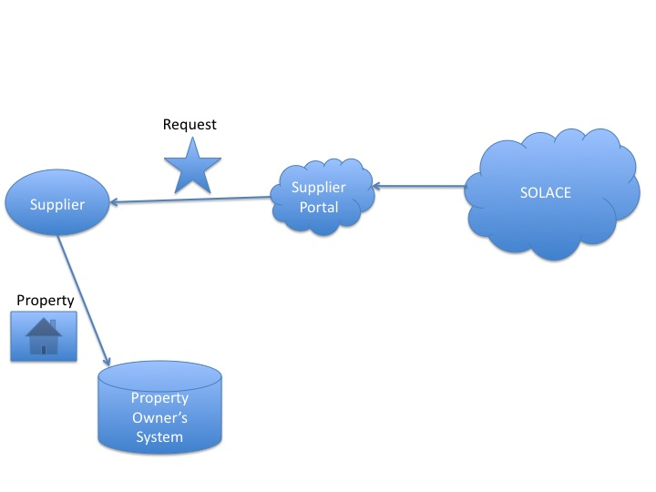

Diagram 8.4 – Request Property

# Features

Below are some of the key features available to users of the Supplier Portal. This list is not all inclusive.

**View bookings and insert owner bookings**

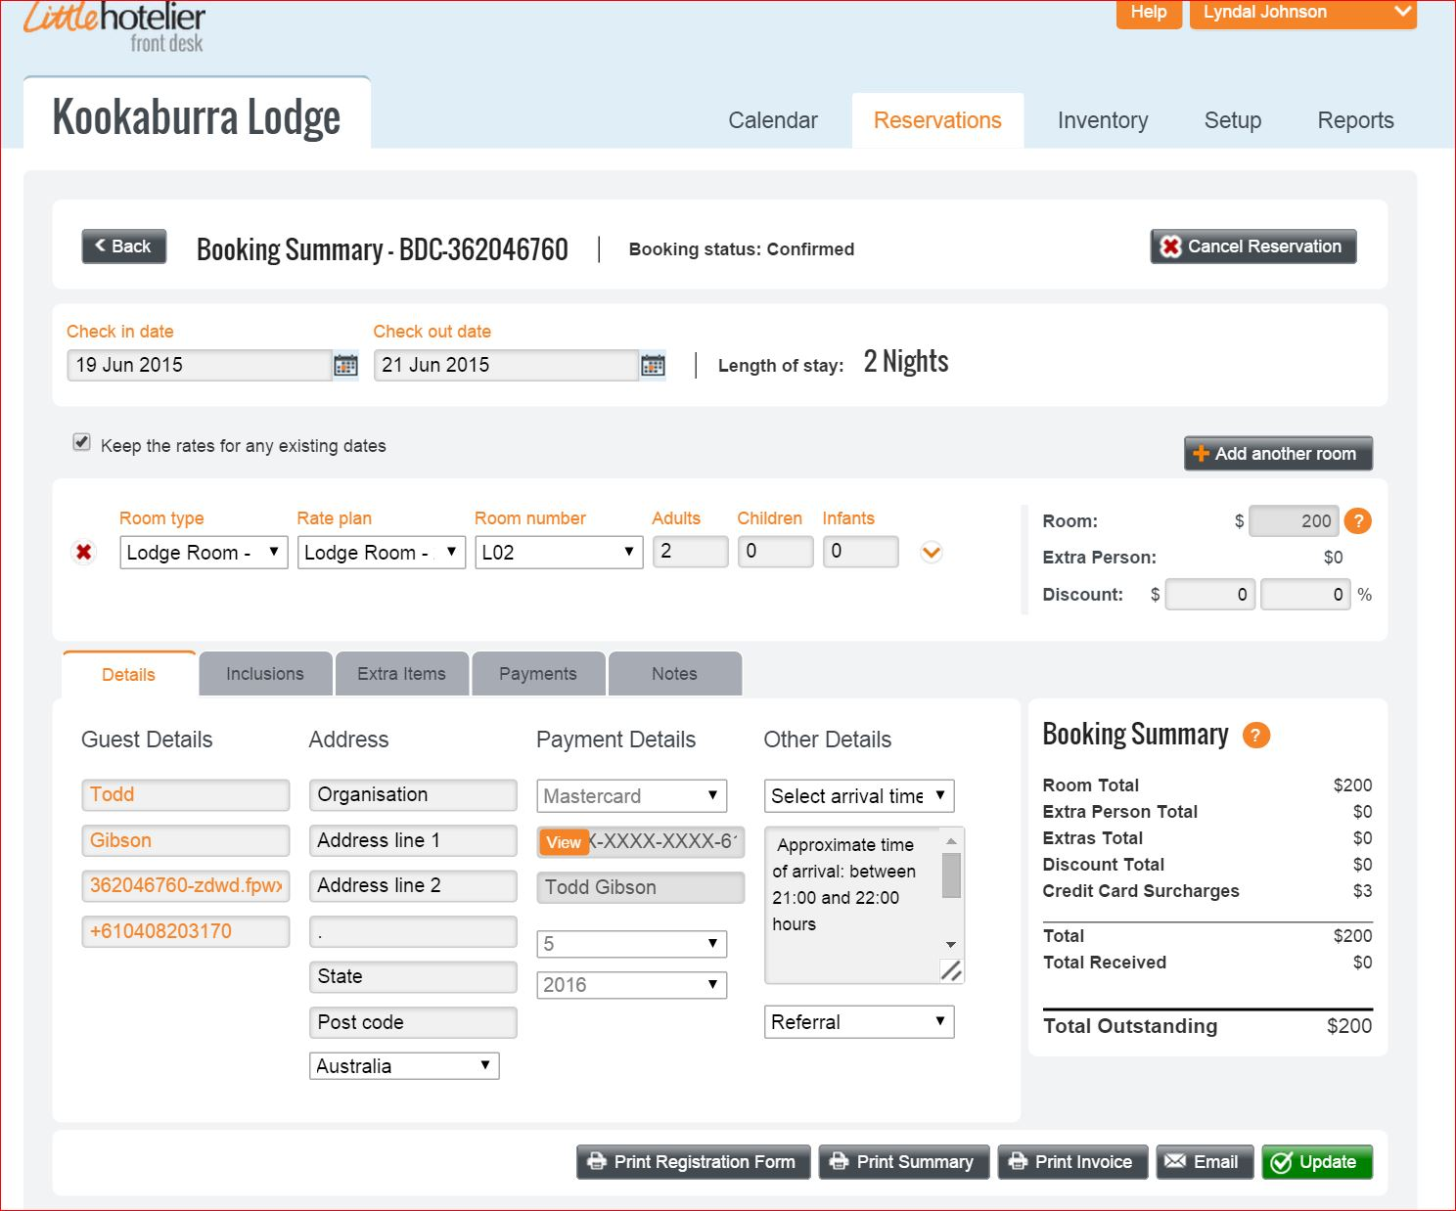

**Highlight periods from a calendar to create an owner booking or block off availability.**

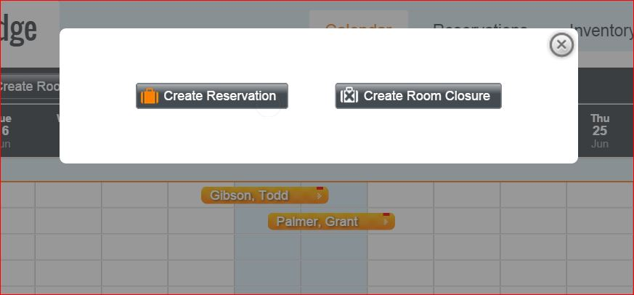

**Allow Suppliers to bulk update all product offerings.**

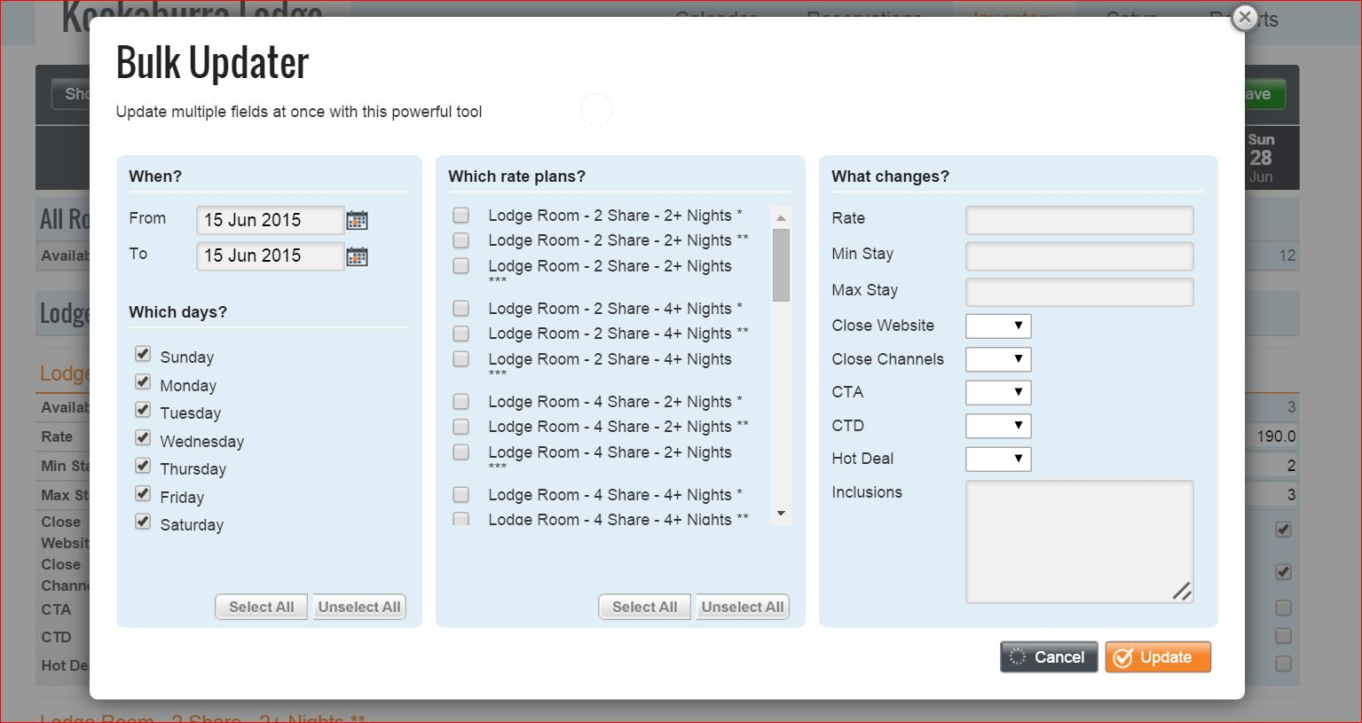

**Intuitive, clean and easy to navigate the set up process. Wizard tool would be ideal.**

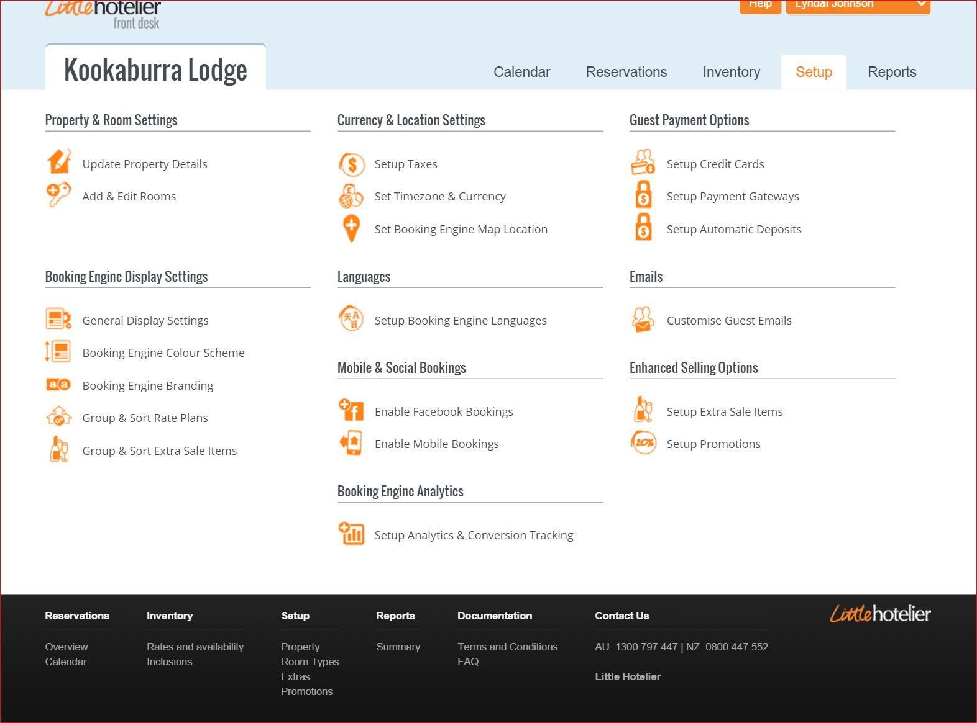

**Content including product descriptions and images that are to be displayed on the Business’ website must be ‘approved’ by the business and there must be an easy and uniform of addressing this requirement in Supplier Portal.**

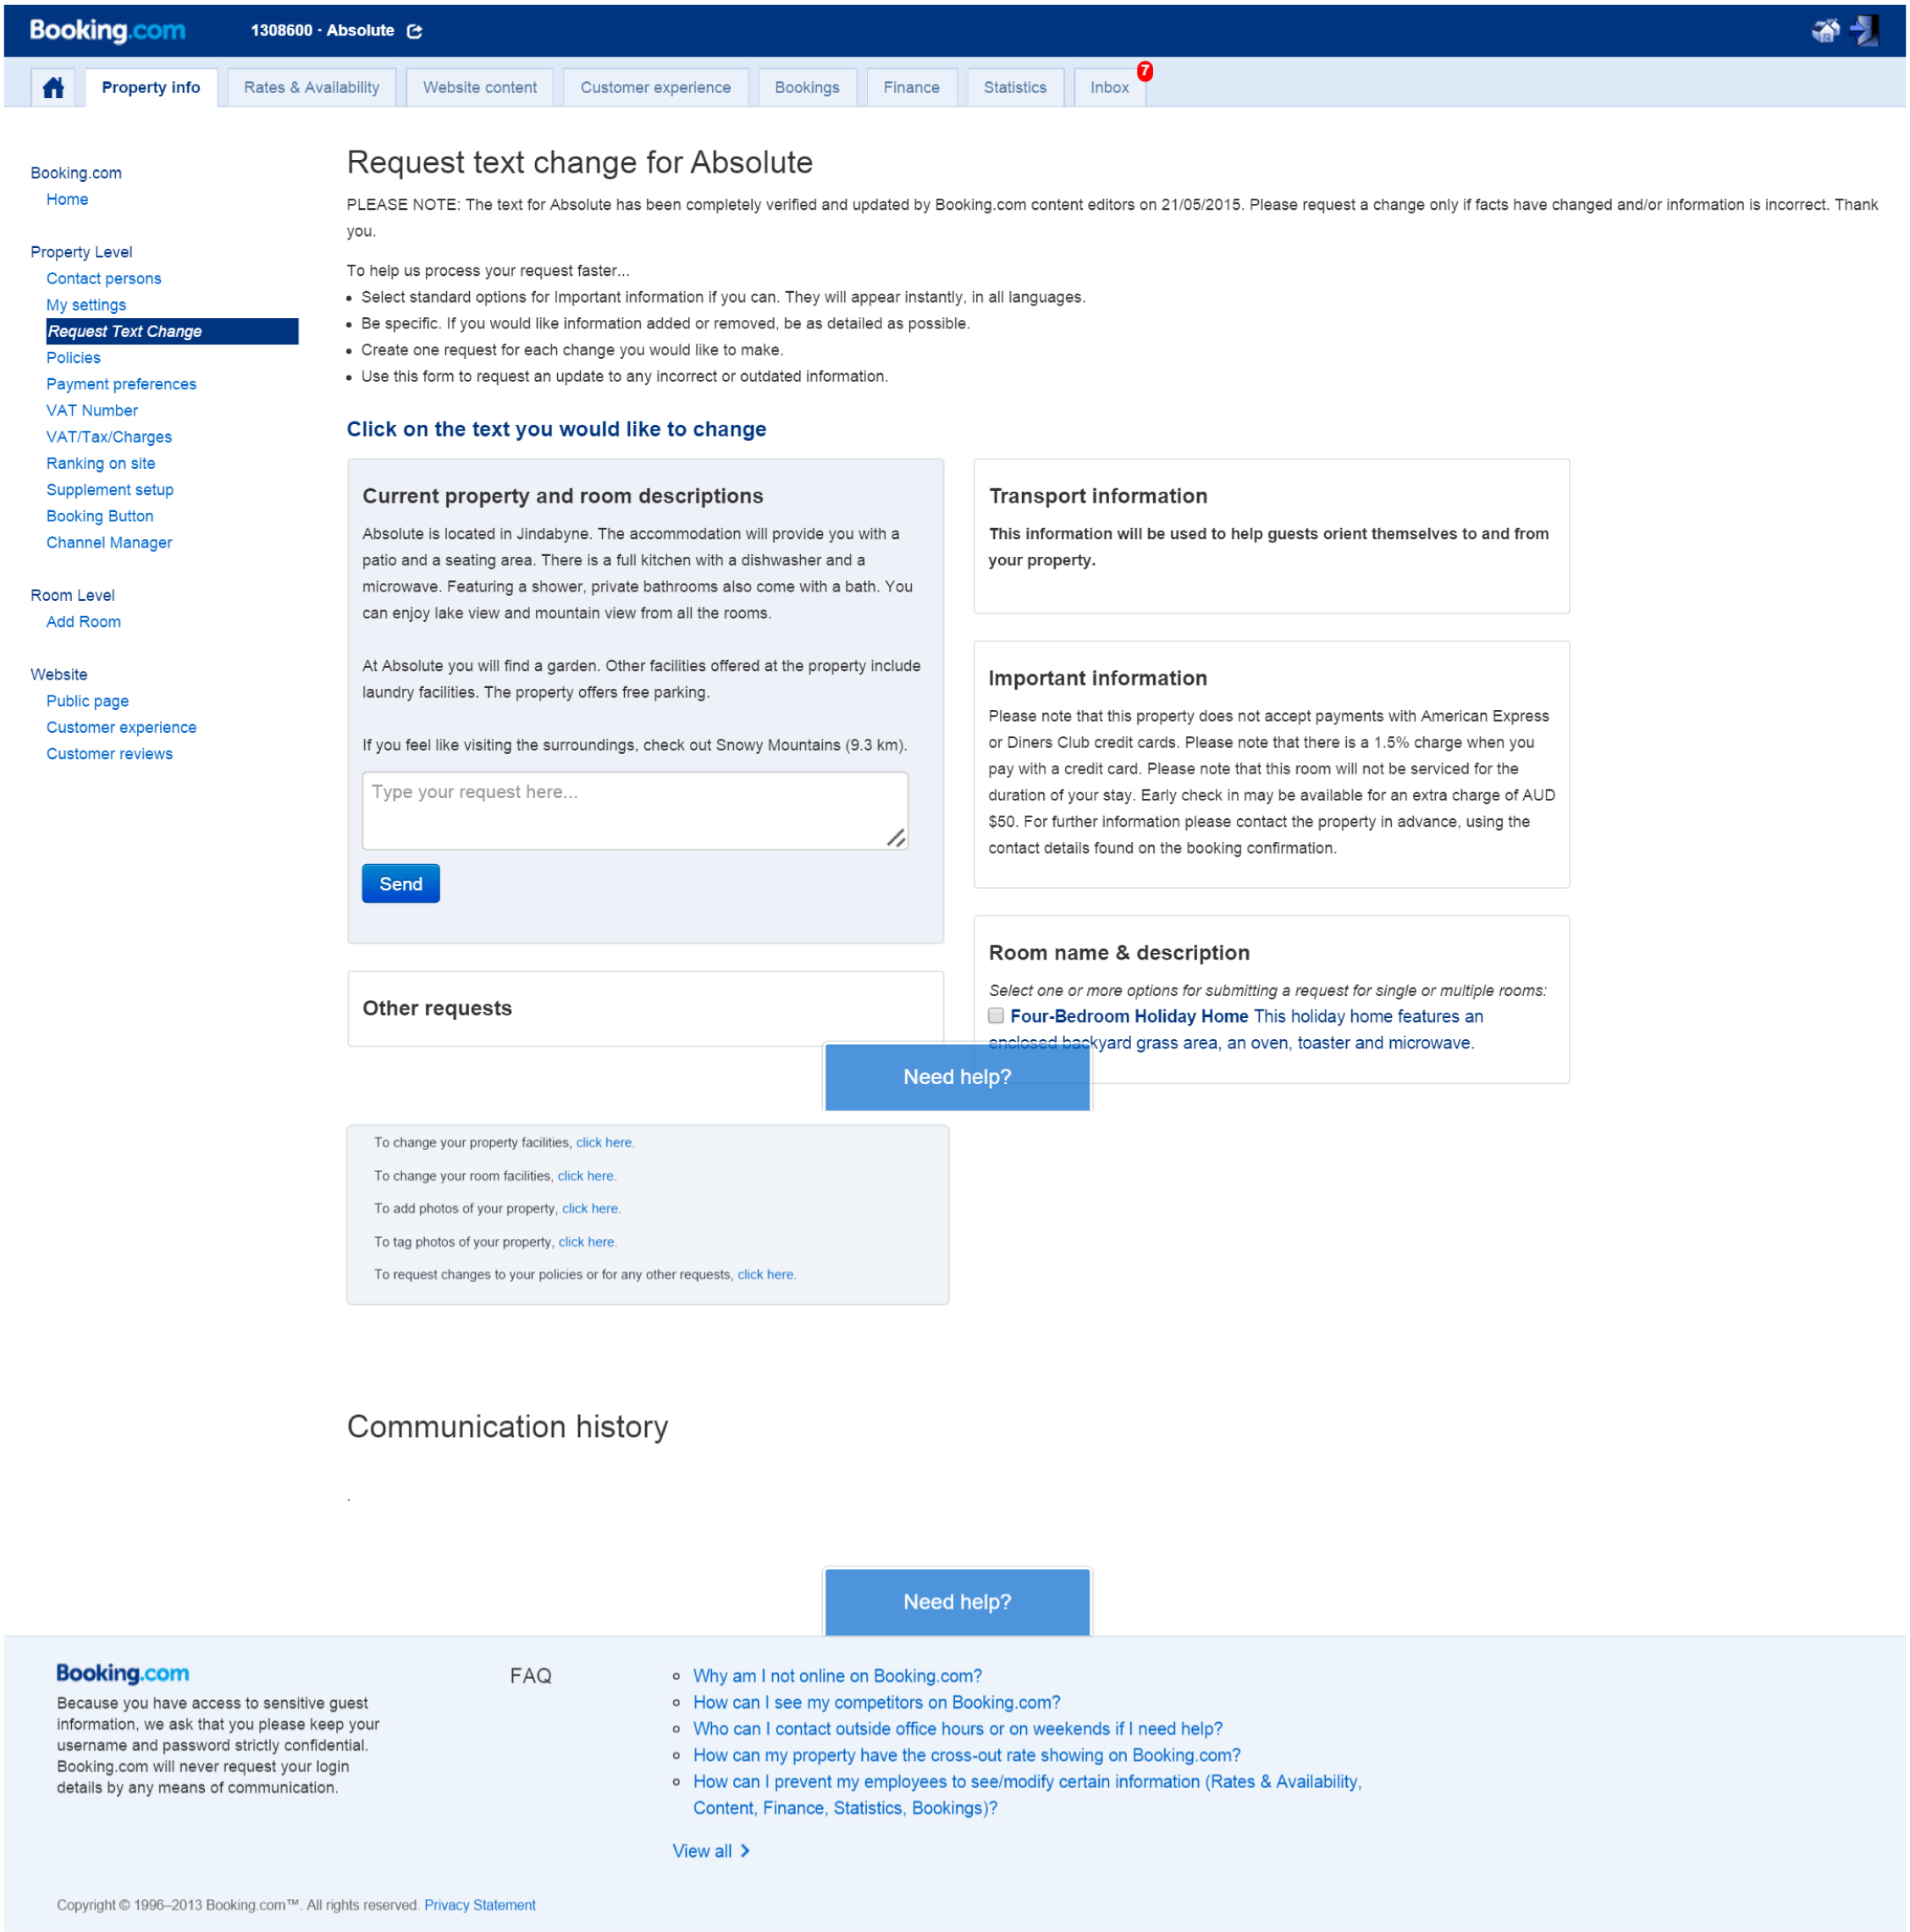

**Offer suggestions to Suppliers on how they could improve their listing. Monitor image quality etc.**

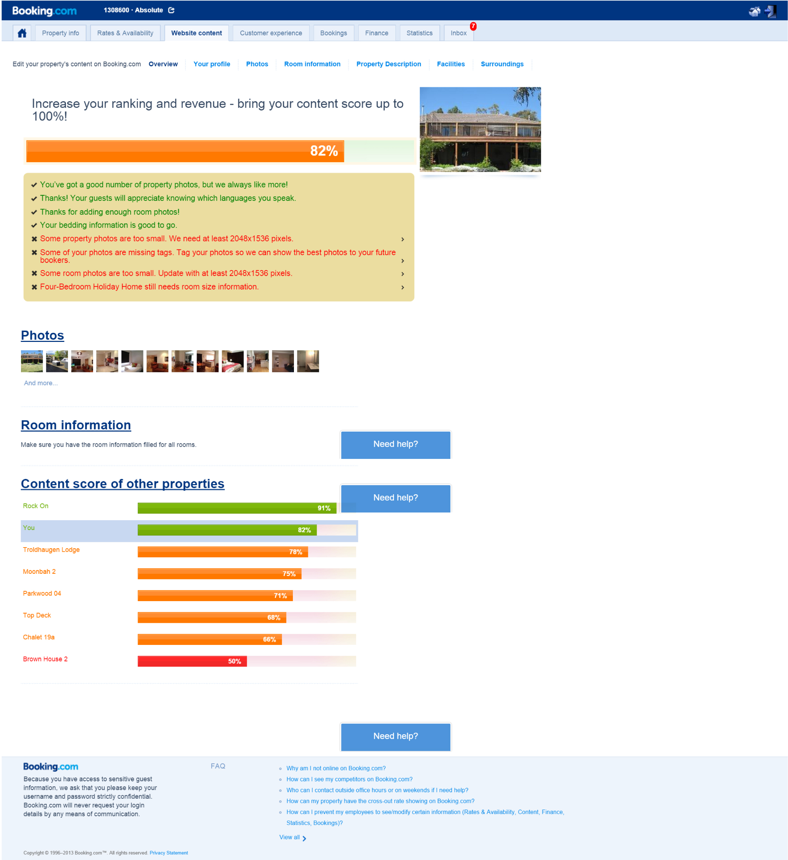

**Attractive, interactive calendar.**

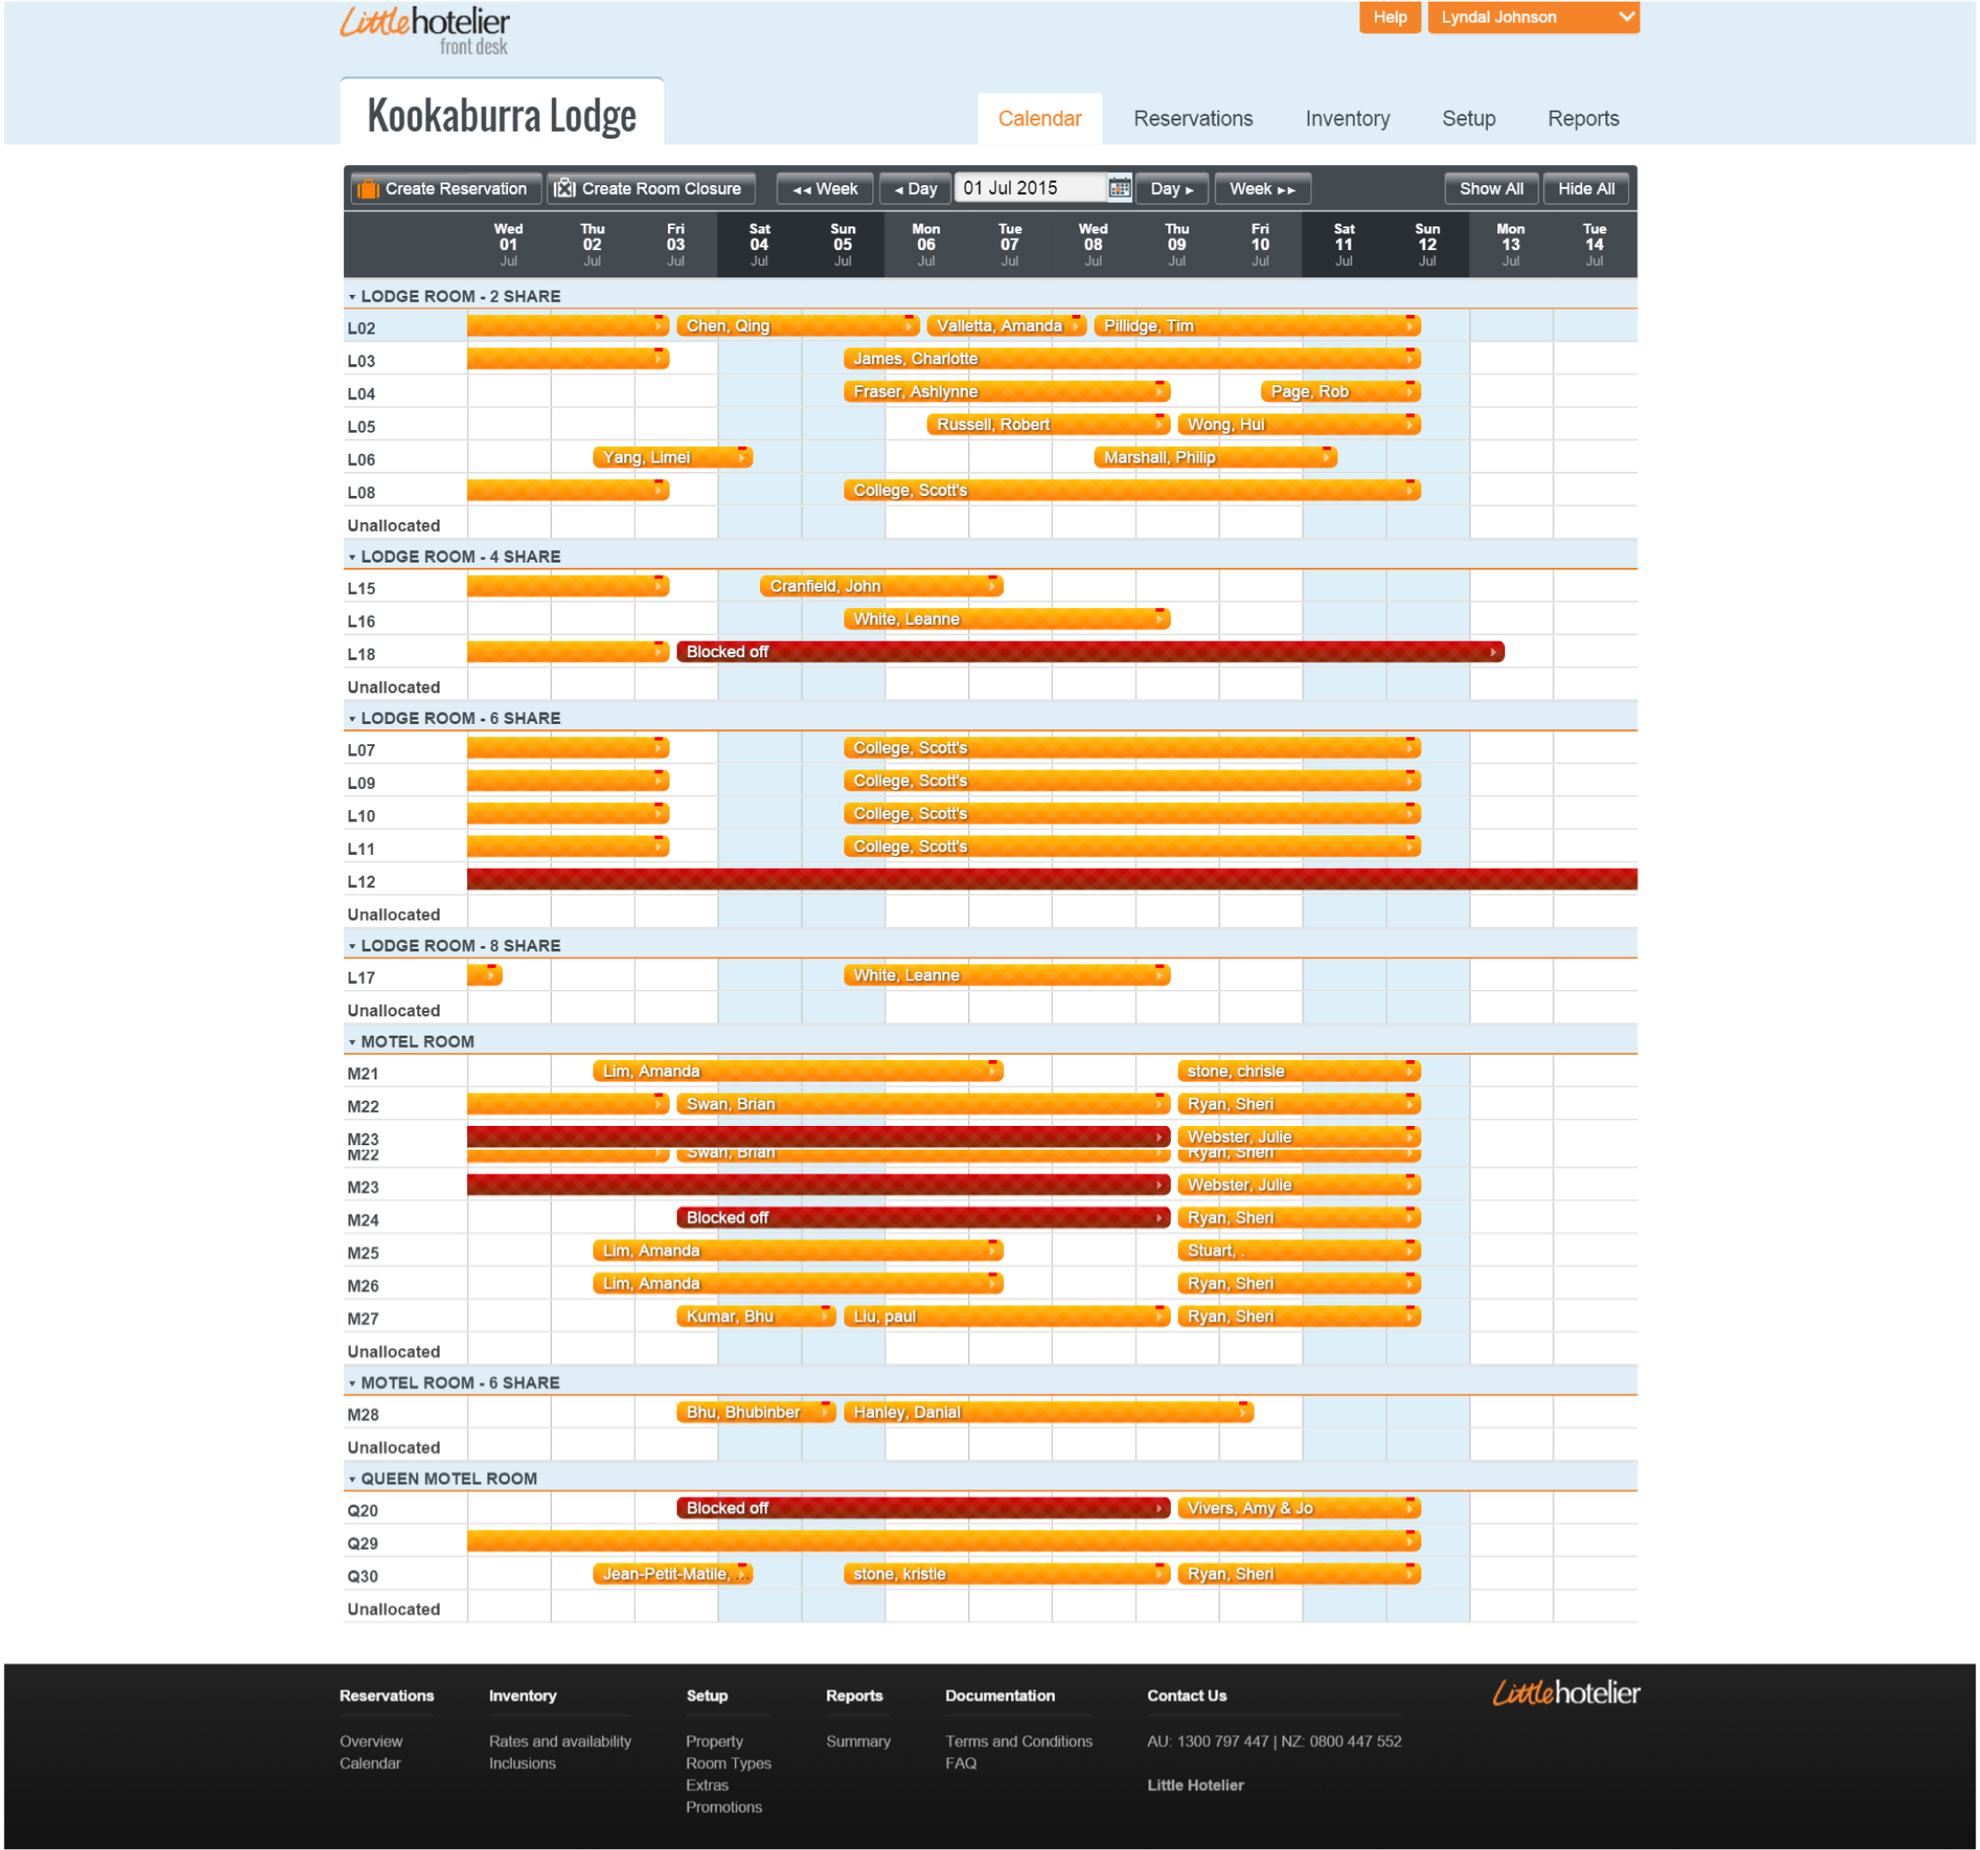

# High Level Experience Flows

Please refer to attached High Level Experience Flow document and sketches.